**Remote Repositories: A Collaboration Powerhouse**

Imagine a central location where you and your team can store and share your project's code, keeping track of every change made. That's the magic of remote repositories! Hosted on platforms like GitHub or GitLab, they act as a central hub for collaboration, version control, and easy access from anywhere.

**Creating Your Remote Repository (Origin Story)**

1. **Head to Your Preferred Hosting Service:** Visit GitHub, GitLab, Bitbucket, or any Git hosting service that suits your needs.
2. **Sign Up or Log In:** Create an account if you're new, or log in if you already have one.
3. **Craft Your Repository:** Click on "New repository" or a similar option to create a new repository. Give it a descriptive name that reflects your project.
4. **Voila! Your Remote Repository Exists:** You'll be presented with a unique URL for your newly created repository. This URL is the key to linking it with your local project.

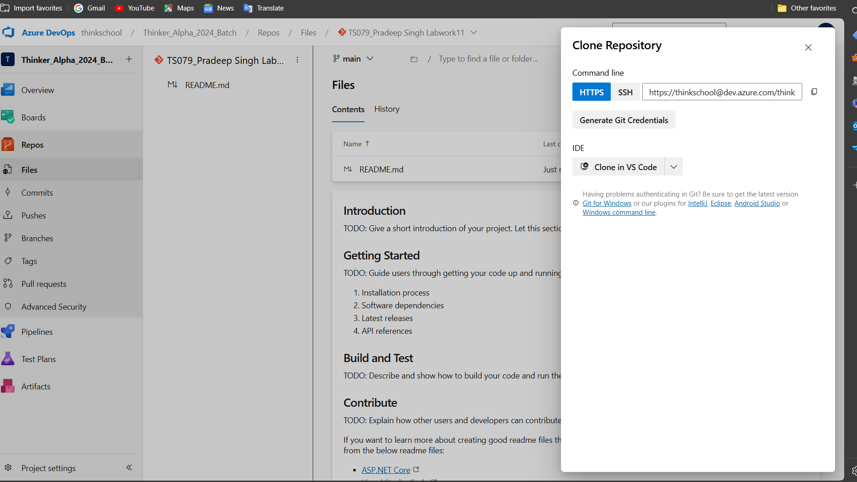**Linking Your Local Project: Bridging the Gap**



1. **Open Your Terminal:** Launch your command prompt or terminal (often accessible by searching for "command prompt" or "terminal" in your start menu).
2. **Navigate to Your Local Project:** Use the cd command to change directories and reach the folder where your local project resides (the one you'll be working on).
3. **The Linking Command:** Now, type the following command, replacing <remote_repository_url> with the actual URL you obtained when you created the remote repository:

git remote add origin <remote_repository_url>

This command essentially tells Git to create a "remote" named "origin" (a common convention) that points to the location of your remote repository on the hosting service.

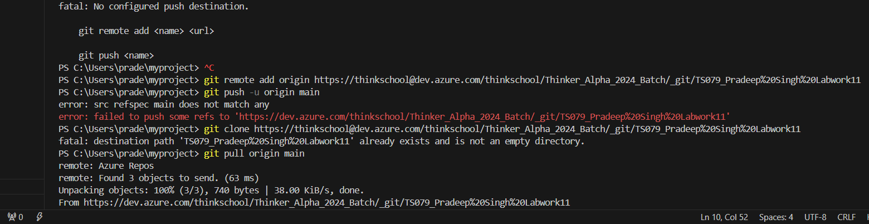



**Pushing Changes to Your Remote Repository: Sharing Your Work**

1. **Ensure You've Linked:** Make sure you've linked your local project with the remote repository using the git remote add command in the previous step.
2. **Stage Your Changes:** Use git add <filename> to add specific files you've modified, or git add . to add all changes in the current directory.
3. **Commit Your Changes:** Create a snapshot of your staged changes with a meaningful commit message using git commit -m "<your commit message>".
4. **The Big Push:** Now, execute the following command to push your local commits to the "main" branch (the default branch name on most platforms) of your remote repository:

git push -u origin main

* + The -u flag (short for "--set-upstream") is crucial here. It not only pushes your changes but also sets the "origin" remote (the one you linked earlier) as the "upstream" for the "main" branch, simplifying future pushes.

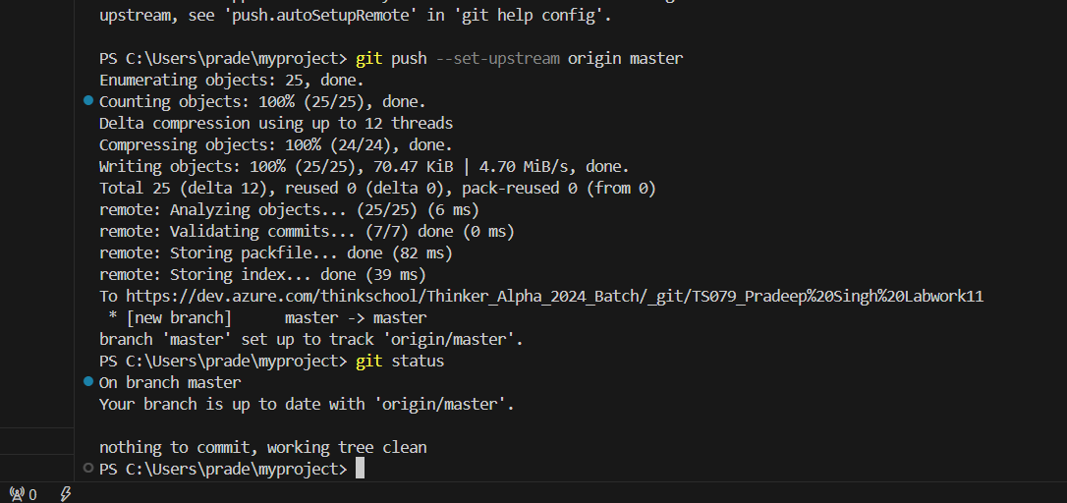**Cloning a Repository: Downloading a Project**



1. **Obtain the Remote Repository URL:** Get the URL of the remote repository you want to clone (download a copy of). This URL is usually provided by the repository owner or found on the hosting service's website.
2. **Open Your Terminal:** Launch your terminal or command prompt.
3. **The Cloning Command:** Navigate to the directory where you want to create a local copy of the repository and type:

git clone <remote_repository_url>

Replace <remote_repository_url> with the actual URL you obtained. This command will download the entire repository, including its history, to your local machine.

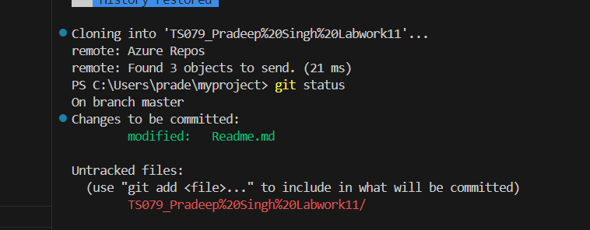



**Pulling Changes from Your Remote Repository: Staying Updated**

1. **Navigate to Your Local Project:** Use the cd command to switch directories and reach the folder where your cloned repository resides.
2. **The Pulling Command:** Execute the following command to fetch any changes that have been pushed to the remote repository's "main" branch since you last pulled:

git pull origin main

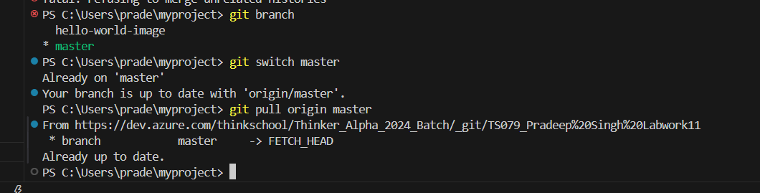



This command retrieves the latest changes from the remote "origin" and merges them into your local "main" branch. It's essential to pull regularly to ensure you're working on the most up-to-date version of the code.

**Remember:**

* Replace <remote_repository_url> with the actual URL in all the commands.
* Always commit your changes with meaningful messages before pushing.
* Pulling updates before pushing helps avoid merge conflicts (conflicting changes).
* Collaborate effectively with your team by following these practices!